**2. Why bigger the sigma is, lower the cancel rate in Bancor Market?**



Figure 3. Figure about cancel rate in Bancor Market. Here the cancel rate is calculated by (total canceled orders / total created orders). The x-axis: **T-R-N-sig**.

notations:

**T**: time interval between time epochs.

**R**: the bouncing range of mean valuation, when time epochs comes.

**N**: customer number

**sig**: the sigma in Gaussian function. Smaller the sigma is, closer valuations are.

**Ps**: the price of smart token in the Bancor market, updated after every transaction

**Psc**: the price of smart token broadcasted by market at every beginning of time slot

**Ans:**

First of all, we need to know, what will happen if the sigma has bigger value.

Bancor-WhitePaper/Figures/Normal_Distribution_PDF.pdf

small sigma

large sigma

Figure 1: The Gaussian function in different sigma settings. Smaller the sigma is, steeper the Gaussian curve is.

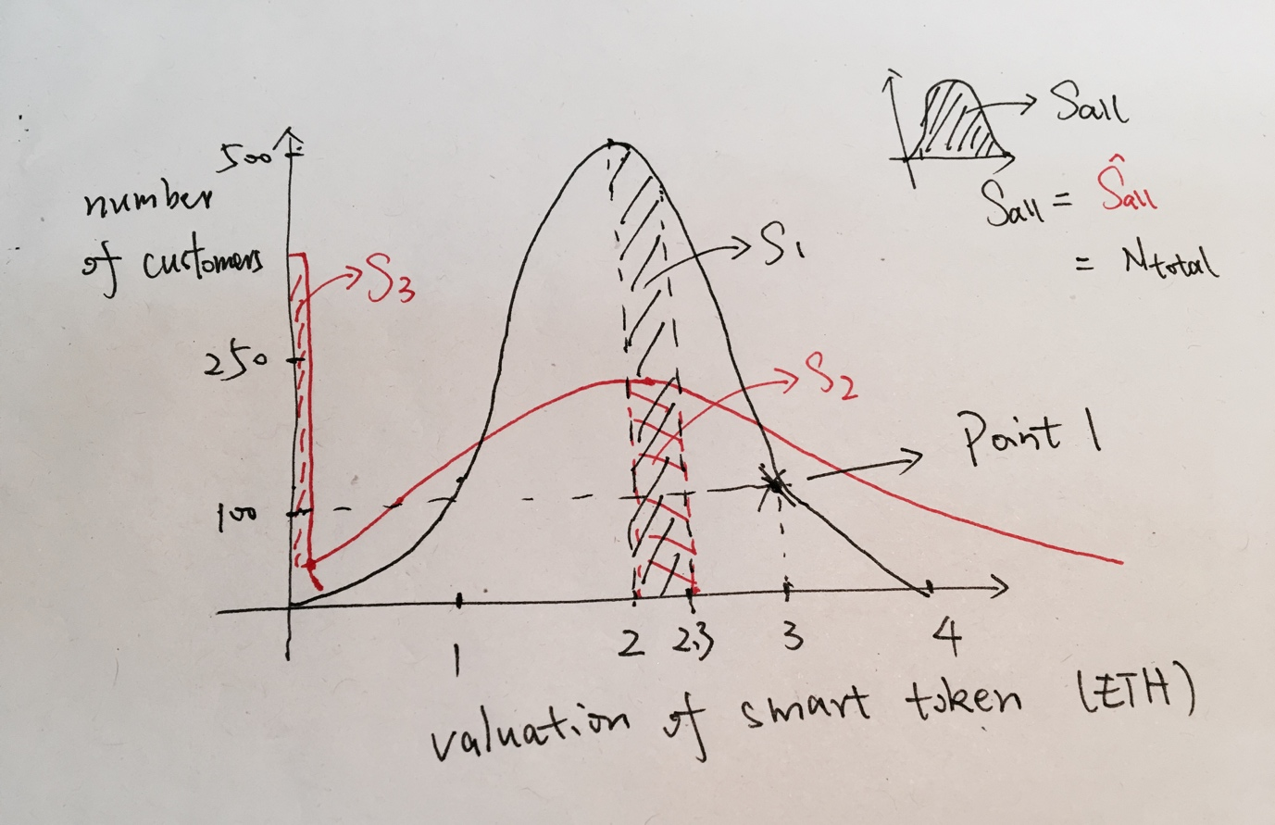

Figure 2: The black curve shows the valuation distribution with **sig1**, the red curve shows with **sig2**. By Figure 1, we know **sig2** > **sig1.** The mean valuation is 2.

Here, we use a simple example by Figure 2, to illustrate why smaller sigma causes higher cancel rate.

The point 1 here means there are 100 customers making valuation as 3 ETH.

Thus, by doing a simple calculus, like small plot in the right-top corner of Figure 2, we know that the total area rounded up by x-axis and Gaussian curve is the total number of customers.

Since both in red curve and black curve, there are totally 2000 customers coming into market, we know that:

**S all** = **S all** = **N total** = 2000 (# of customers)

When one customer successfully making his transaction, the price of smart token in market will fluctuate, from 2 to 2.3 for instance in Figure 2.

**In this case, the blacked shadowed area in Fig2 or the red shadowed area presents the number of customers who now cannot make transactions. (buy-order valuation smaller than current price of smart token)**

**Hence, the current probability of customers' order being canceled in black-curve distribution: Pr = S1/S all = S1/N total.**

**Similarly, Pr = S2/S all = S2/ N total.**

Apparently, **S1 > S2**. Therefore, in current state, **Pr > Pr.**

In fact, whether the price of smart token is increasing or decreasing, **Pr** is **always** larger than **Pr**. This indicates, **at every time**, the probability of transaction being canceled in Black curve Gaussian distribution (with **sig1**) is larger than it in red curve (with **sig2**).

Combining with the fact that **sig2** > **sig1**, the prove of smaller sigma causing higher cancel rate is done.

-------------------------------

If you are careful enough, you might notice the weird S3 area.

This is because when the valuation by Gaussian function is smaller than 0, we set this valuation to be 0.001 \* mean valuation (in Figure 2 is 0.002). Therefore, S3 actually equals with number of customers who generate valuation smaller than 0.

for i in range(custNum):

  if custValuation\_list[i] < 0:

      # Customer does not want to sell their token in free.

      # Here we give them a small valuation when valuation < 0

      custList[i].changeValuation(0.001\*currentMarketPrice)

  else:

      custList[i].changeValuation(custValuation\_list[i])

Actually, S3 does not disturb the prove at all, since larger the S3 is, smaller the S2 is.